Week 6 Work Log: Innovation Strategy and Technical Implementation

Complete this worksheet as a team during or after the Week 6 workshop. Add more rows if needed.
Group | Forecasting 4 | Workshop | Thursday 3:30pm – 5:30pm
Project title | AI-Powered Energy Prediction: Forecasting Model Development | Date | September 18, 2026
Client | ARC Research Hub for Integrated Energy Storage Solutions | Members present | Yaqiao, Bhumika

  - Activity 1
Test your project against all four types before choosing. Most student projects claim to be disruptive and are actually incremental or architectural that is not a criticism, but it should change what you promise the client.

Innovation type | Does this describe your project? (Y/N) | Evidence from your own project
Incremental | Y | We combine existing methods (LSTM, XGBoost, error reciprocal, SHAP/LIME) in a new way. Literature [5][6][8][9] shows these components work, but few studies integrate them into one lightweight prototype.
Disruptive | N | We are not replacing existing forecasting methods or creating a new market.
Radical | N | We are not inventing a new algorithm or a new technology.
Architectural | N | We are not reconfiguring the whole system architecture. We focus on one specific pipeline.

Type that best fits, and why | Incremental. Our project improves an existing approach by combining proven methods and adding interpretability. It does not create a new algorithm or disrupt the market.
What this classification changes about how you build | We should focus on making the combination work reliably, not on inventing something new. We also need to be clear about what is new (the combination + interpretability + multi-dataset validation) and what is borrowed.

  - Activity 2 Innovation goals and focus
Write SMART goals: each one needs a measure and a date, not an aspiration. Then place your project on the innovation matrix - competence is what your team can do, commitment is how much of your time and effort is actually going in.

# | Innovation goal (specific) | How measured | Why relevant to the client | By when
G1 | Train a baseline XGBoost model on the cleaned PJM dataset and record MAE, RMSE, and MAPE. | Metrics recorded in GitHub/docs/results/.  MAE = 335.78 MW, RMSE = 451.25 MW and MAPE = 1.066% | The client needs a working prototype with at least two model. | Week 7
G2 | Train an LSTM model and compare it with XGBoost using the same test period. | Model comparison report in GitHub. | The client wants an evaluation matrix for model comparison. | Week 8
G3 | Apply SHAP and LIME to explain at least three predictions and produce one plain-English summary. | SHAP/LIME plots + summary saved to GitHub. | The client wants improved interpretability for grid operators. | Week 11

Competence ↓ / Commitment → | Low commitment | Medium commitment | High commitment
High competence
Medium competence |  | Team has foundational ML /Python skills | Only two active members are covering all technical and documentation work
Low competence

  - Activity 3 Bridging strategy to technical execution
This is the core of the session. Each strategic objective must become a technical requirement, a technology choice, and a milestone that would demonstrate it. An objective with no milestone is a slogan.
Strategic objective | Technical requirement it becomes | Technology / tool chosen | Milestone that proves it
Build a multi-model forecasting prototype | Train at least two types of ML/DL models and compare them | XGBoost, TensorFlow/Keras, scikit-learn | Model comparison report (Sprint 3)
Improve interpretability | Generate feature importance and prediction explanations | SHAP, LIME | SHAP/LIME plots + plain-English summary
Ensure the solution works on different data | Build a reusable data-cleaning pipeline that adapts to different datasets | Python, pandas | PJM dataset cleaned (done); pipeline applies to Household Electric Power and Real-E datasets

Emerging technology you are using (AI, IoT, blockchain, other) | AI (deep learning + ensemble learning + explainable AI)
What it buys you that a conventional approach would not | A conventional ARIMA model cannot capture non-linear patterns or explain individual predictions. Our approach combines accuracy (LSTM + XGBoost) with transparency (SHAP/LIME), which helps grid operators trust the system.

  - Activity 4 Cross-functional team and Agile practice
Record who owns what, and what each member is learning. Then state how your team actually works rather than which framework you have heard of.

Member | Role on this project | Responsibilities they own | Skill they are developing
Yaqiao Chi | Team leader & technical lead | LSTM model, Design Justification, Milestones & Risks, overall integration | LSTM implementation technical writing
Bhumika Sharma | Methodology & documentation lead & technical lead | Methodology, Executive Summary, workflow diagram, initial EDA, time-based and lag feature engineering, preprocessing, XGBoost baseline and model evaluation | Technical writing, feature engineering, model evaluation and ML implementation
Vidhi Patel | (no active role) | None since Week 3 | N/A
Marwa Aldhafeeri | (no active role) | None since Week 3 | N/A

Activity 5 Current technical state of your project
Report what exists, not what is planned. A module counts as working only if someone outside the team could run it from your repository.
Component / module | Status (not started / in progress / working) | What it does today | Evidence (commit, screenshot, demo)
Data cleaning pipeline (PJM) | Working | Cleans PJM dataset: removes duplicate timestamps, fills missing hours, checks outliers | Notebooks/data_cleaning.ipynb on GitHub  https://github.com/Yaqiao-chi-helen/Forecasting-team4/tree/main  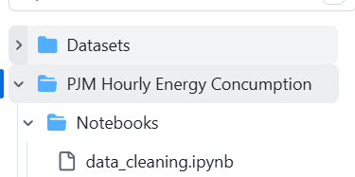
Dataset (cleaned PJM) | Working | 145,366 rows, 8 duplicates removed, 30 missing hours filles | Data/processed/PJME_hourly_cleaned.csv on GitHub  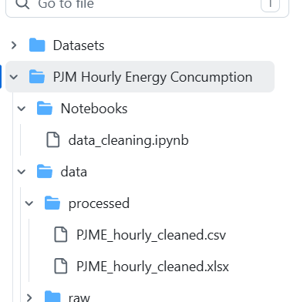
EDA | Working | Examines dataset structure, missing values, duplicates, descriptive statistics and electricity-demand patterns over time. | 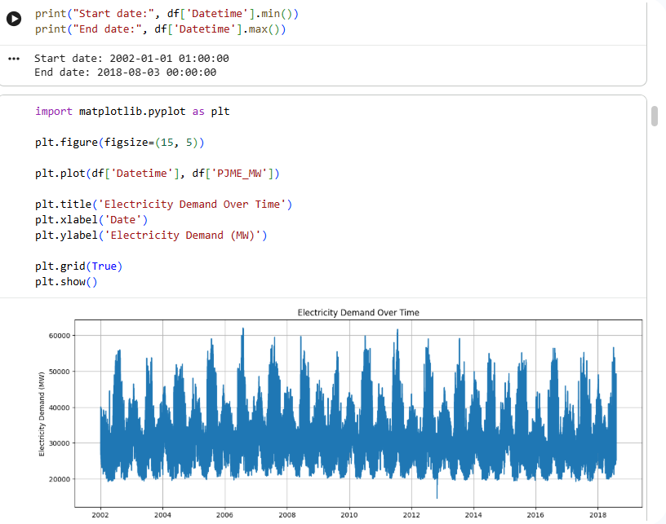-
Feature engineering | Working | Created hour, day, month, day-of-week, weekend and lag features (1h, 24h, 168h) | 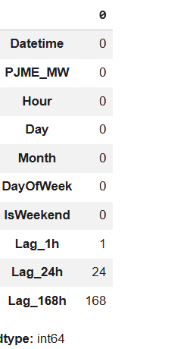-
XGBoost baseline | Working | Trains and XGBoost regression model and generated electricity demand predictions. | 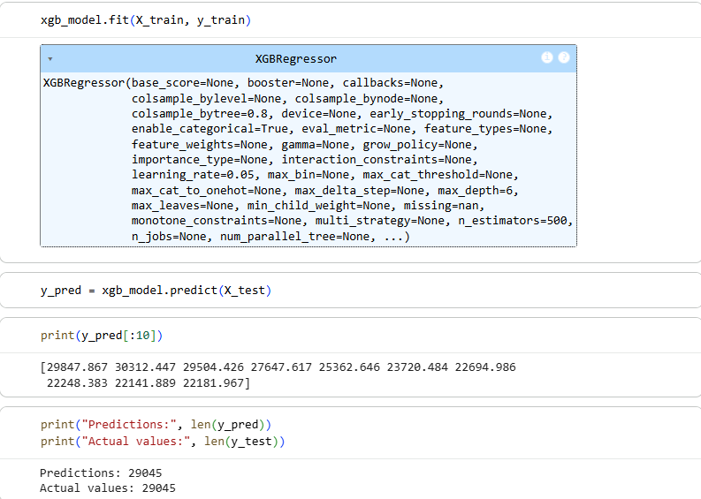and  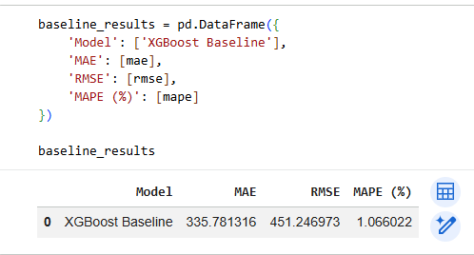
LSTM model | Not started | - | -
SHAP/LIME analysis | Not started | - | -
Innovation Concept report | Working | Report finalized and submitted via Canvas, covering Design Concept, Methodology, Specification, Milestones & Risks, and Design Justification | 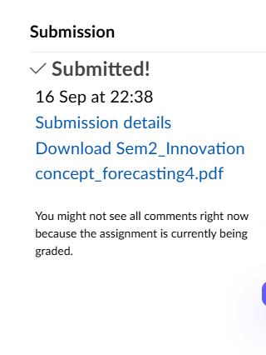

Biggest technical blocker right now | LSTM implementation. The team has foundational but not expert knowledge in deep learning.
What you need to unblock it, and from whom | More time for learning LSTM tutorials, and support from the tutor if needed. Yaqiao is leading this.
Percentage of planned build complete, and how you judged that | Data cleaning is done. Feature engineering and model training are almost halfway.
Contribution register

Every member completes at least one row in their own words. Mark each task M for management (planning, client contact, minutes, scheduling, risk, document control) or T for technical (research, requirements drafting, design, prototyping, testing, tooling). Evidence must be something the tutor can open; rows without evidence do not count.

Member name | Task / activity completed this week | Type (M / T) | Evidence (link, file, commit, minutes) | Time spent (hrs)
Yaqiao Chi | Cleaned and preprocessed the PJM Hourly Energy Consumption dataset; uploaded the cleaned dataset and cleaning notebook to GitHub; finalized and submitted the Innovation Concept report via Canvas; researched the implementation steps for the LSTM model to prepare for the next stage of development | M & T | 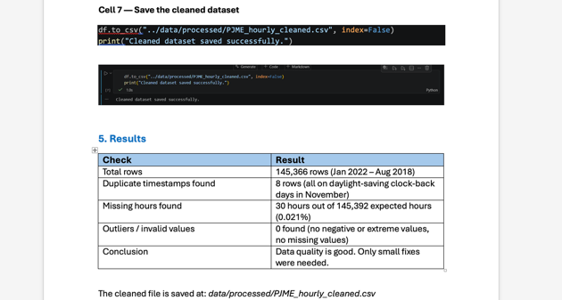  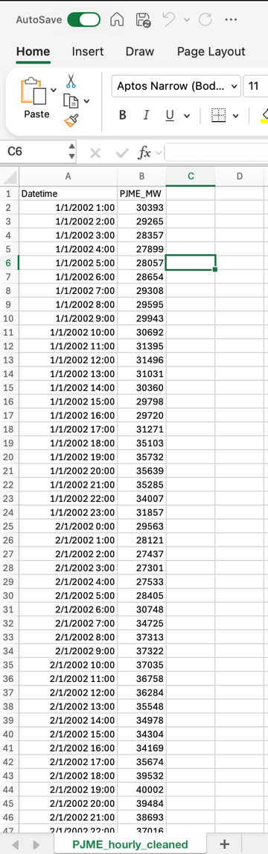  GitHub link: https://github.com/Yaqiao-chi-helen/Forecasting-team4 | 12.5 h
Bhumika Sharma | Completed initial EDA on the cleaned PJM dataset; performed time-based and lag feature engineering; prepared the chronological train/test split and preprocessing; set up TensorFlow/Keras in Google Colab; developed and trained the XGBoost baseline; evaluated the model using MAE, RMSE and MAPE; documented the baseline results. | M & T | 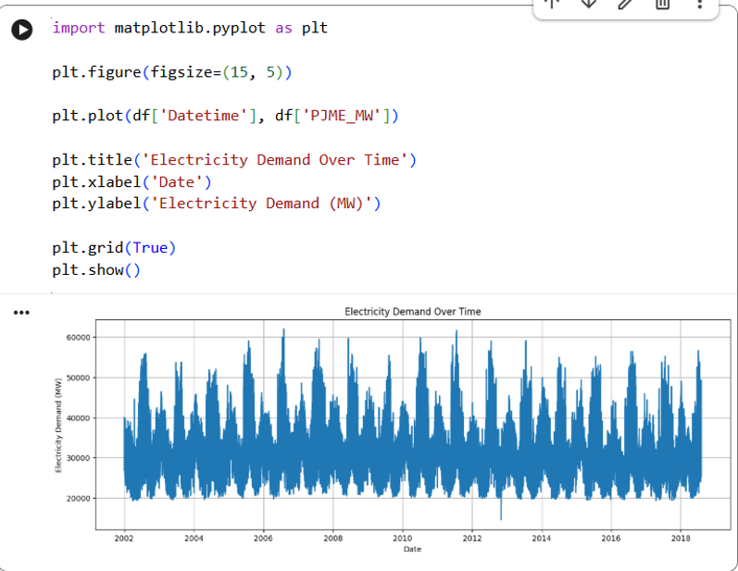(feature engineering and lag features training)  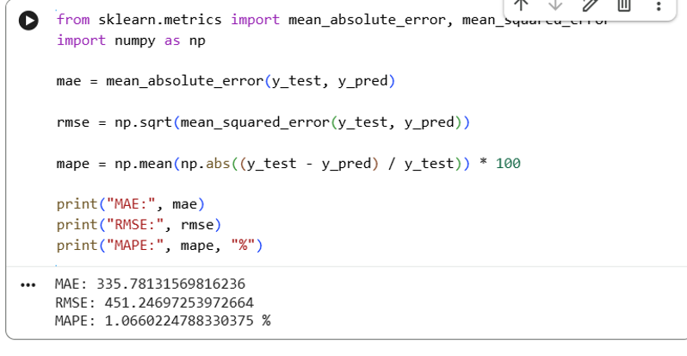(mae, rmse, mape baseline) | 11 hours
Vidhi Patel | No any responding |  |  | N /A
Marwa Aldhafeeri | No any responding |  |  | N /A

Agreed actions for the coming week

Owner | Action to complete before next workshop | Due date
Bhumika / Yaqiao | Combine LSTM and XGBoost predictions using error-reciprocal weighting | Next Thursday
Bhumika | Apply SHAP/LIME to XGBoost baseline predictions | Next Thursday
Yaqiao | Develop and train LSTM model on Google Colab | Next Thursday

Anything blocking the team, or any contribution imbalance the tutor should know about?

Vidhi and Marwa have made zero contributions since Week 3. No workshop attendance, no task completion, no response to messages. This was escalated to the tutor in Week 5. The remaining two active members (Yaqiao and Bhumika) are covering all work. The project is still on track, but if either active member falls behind, the project will be at risk. We will continue to monitor and update the tutor if needed.

